**Exploratory spatial analysis of crimes in Northern Ireland**

**How to guide**

Link for the project: <https://github.com/syedazahrakazmi/zahra>

**Introduction**

Crimes happen in every part of the world. Many factors like social, economic, and geographical are responsible for crimes (Erdogan et al 2012). Globally one of crucial factor is prevent development of the areas that show a risk of becoming crime centres(Ramirez et al 2019). In order to manage the city both financially and orderly It is important to have information about locations and reasons of crimes, so that eradication measures can be taken (Silva et al 2020).

Although statistical analysis when combined with the GIS provides useful results, using the python code saves time and makes the analysis time saving. The following code uses the Exploratory spatial analysis methods for crime analysis in Northern Ireland.

**Literature review**

Gotway et al 2003 investigated use of exploratory spatial data analysis. According to the researcher one among the diverse uses of ESA is to use it with visualisation techniques like GIS.The researcher further suggests that although the statistical people will like the visualisation on the other hand it will be beneficial for other people to choose right method of data and help in choosing the correct application.

Smith et al 2020 used exploratory spatiotemporal analysis in land use change in NNW in St Louis demolition site. The researcher compared pre and post demolition scenario. The researcher found a buffer area fhelpful for crime reduction in demolition site.

Ramirez et al 2019, investigated crime in Mexico City using exploratory research methods. The researcher used official crime data, twitter data and google trends data for analysis of patterns and type of crimes in different areas of the city. Researcher found that the statistical analysis in combination to the online data source as a useful technique.

Silva et al 2020 investigated homicide rates in Brazil using exploratory spatial analysis methods between the years 2016-2019. Researcher suggests to use resources to improve socio economical state as helpful for crime reduction

Chocholata 2018 investigated analysis of crime in Czech Republic, Hungary, Poland and Slovakia. The researcher used ESDA and established the crimes are not only affected by economic and demography but also number of crimes in neighbouring areas.

Resch et al 2018 investigated crimes around football stadiums using ESDA methods. Researcher used Spatial statistics, text mining and spatial clustering. The researcher suggests that the twitter data can be used for future crime prediction.

Erdogan et al 2013 studied the property crime using a 12-year data from 1997-2009. The researcher deployed exploratory spatial statistical methods to investigate the correlation between property crimes, Economic conditions and socio-demographic and urban factors.

**A setup/installation of code**

The code uses the Jupiter notebook. It is important to use the right version of the python (Python 3.9) and to make sure that all the libraries are installed. List of libraries is as follows:

1. Download the code
2. Download the data
3. Run the code in Jupiter notebook
4. 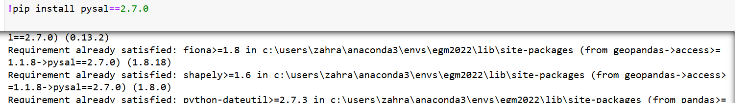As a first step check if all the libraries are installed using command in Jupiter directly

If the libraries are installed requirement already satisfied output is received other wise it gets installed. List of libraries we will use is as under:

Ein Bild, das Text enthält.

If there is an error of module not found use:

!pip install name of missing module

**Read the data**

Data can either be downloaded from the link provided or optionally can be downloaded from the data folder. Links are as under:

* Link to repository in this section: [*https://github.com/syedazahrakazmi/zahra*](https://github.com/syedazahrakazmi/zahra)
* Test data link: *https://data.police.uk*

**RESEARCH METHODOLOGY**

The present study investigates crimes using Exploratory spatial data analysis techniques using the python code. It includes the spatial distribution of different types of crime according to LGD s, Kernel density of top three crimes and hotspot identification.

To achieve the objectives of the study Secondary data will be used.

Data for the crimes is Downloaded from https://data.police.uk as .csv

**SECONDARY DATA**

Two types of data are downloaded (.csv)and cleaned to be used for code:

* First dataset contains information about LGDs to make the polygon map of Local Government districts
* The second dataset contain the crime data for example types of crimes and the location of crimes with latitude and longitude information

**Analysis**

Distribution as per lgd is also visualised for the crime distribution. Inaddition, Kernel density identifies the three most prevalent crimes. Moreover, through the hot and cold spots identification crime centre are identified

* A general picture of crime distribution shows more crimes clusters in eastern part of NI with the biggest cluster in Belfast.
* Crimes are occurring more in urban areas as compared to rural areas.
* Crimes and income deprivation are correlated.

**Suggestion**

* Future research should consider firstly an in-depth study of socioeconomic factors contributing this specific distribution of crimes and crime clusters.

**Expected Result**

The code aims at conducting the clustering analysis for hotspot identification and to visualise the result.

The code will perform the following functions when run:

* Read the data from .CSV

Ein Bild, das Text enthält.

* Clean the data

Ein Bild, das Text enthält.

* 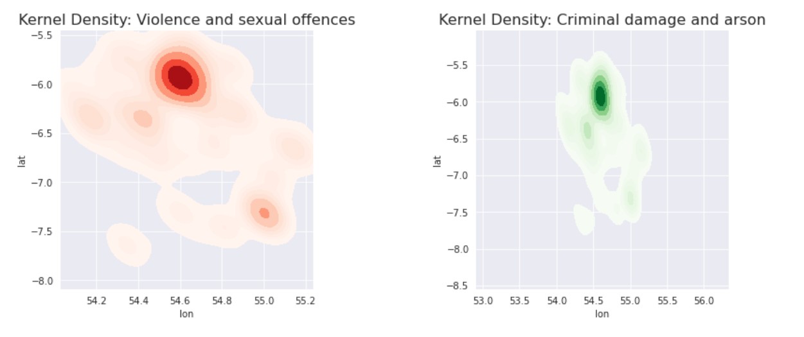Three kernel density maps of the most frequent crimes
* 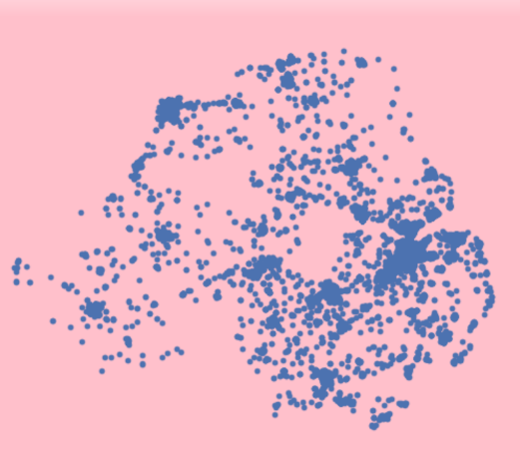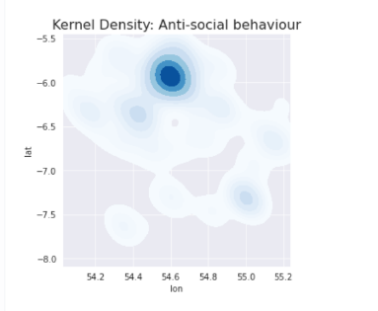Displaying crime data from csv
* Import the LGD map through the shape file

Ein Bild, das Karte enthält.

* Displaying LGD and crimes together: Aim was to display them on top of each other

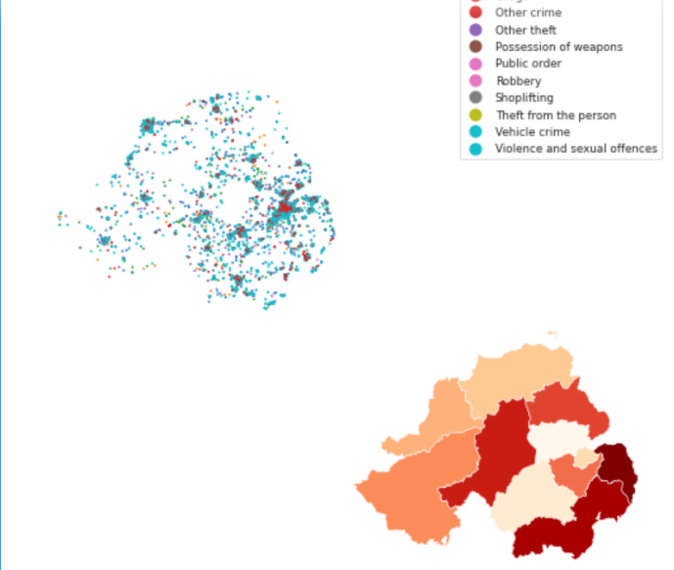

* Choropleth maps on deprivation index: income deprivation (a), employement deprivation(b) and population(c)

Ein Bild, das Karte enthält.
Ein Bild, das Karte enthält.
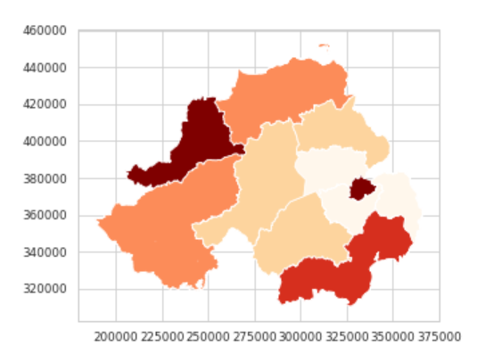

* Ein Bild, das Text enthält.

  Automatisch generierte BeschreibungCrime heat map

**Troubleshooting**

1. **Module not found error**

One common problem encountered is module not found error. It is important that we check that all the libraries required to run the code are installed. Libraries can be installed directly in jupyter note book as well using code snipet:

!pip install name of library

For example if the error was no module named numpy, it will be as followed:

!pip install numpy.

The same code snipet first check if the package is already installed and informs. If its not installed it installs it immediately.

1. **One positional argument expected instead of two**
2. **Drop and rename the columns èrror ‘expected columns 7 but 6 found’**

This error can be corrected by renaming the missing name for abbreviation

**References**

Smith, T.A. and Sandoval, J.O.N., 2020. An Exploratory Spatial Analysis of the Urban Crime Environment around the Next National Geospatial-Intelligence Agency West Development. *The Geographical Bulletin*, *61*(1), pp.37-53.<https://www.ons.gov.uk/>

Smith, T.A. and Sandoval, J.O.N., 2020. An Exploratory Spatial Analysis of the Urban Crime Environment around the Next National Geospatial-Intelligence Agency West Development. *The Geographical Bulletin*, *61*(1), pp.37-53.

Ristea, A., Kurland, J., Resch, B., Leitner, M. and Langford, C., 2018. Estimating the spatial distribution of crime events around a football stadium from georeferenced tweets. *ISPRS International Journal of Geo-Information*, *7*(2), p.43.

Piña-García, C.A. and Ramírez-Ramírez, L., 2019. Exploring crime patterns in Mexico City. *Journal of Big Data*, *6*(1), pp.1-21.

Messner, S.F., Anselin, L., Baller, R.D., Hawkins, D.F., Deane, G. and Tolnay, S.E., 1999. The spatial patterning of county homicide rates: An application of exploratory spatial data analysis. *Journal of Quantitative criminology*, *15*(4), pp.423-450.

Krivoruchko, K., Gotway, C.A. and Zhigimont, A., 2003, November. Statistical tools for regional data analysis using GIS. In *Proceedings of the 11th ACM international symposium on Advances in geographic information systems* (pp. 41-48).

Fotheringham, A.S. and Charlton, M., 1994. GIS and exploratory spatial data analysis: An overview of some research issues.

Chocholata, M., 2018. Spatial econometric analysis of crime: Evidence from NUTS 3 regions of V4 countries. *Economic and Social Development: Book of Proceedings*, pp.194-202